BCUHB Antiplatelet Guidance for Dental Treatment
This guidance relates to the management of patients taking antiplatelet therapy for a cardiac condition and who are undergoing dental treatment. Please refer to the 2022 Guidance from the SDCEP on the management of dental patients taking anticoagulant or antiplatelet drugs (SDCEP Management of Dental Patients Taking Anticoagulants or Antiplatelet Drugs (2nd Edition))
Principles
- Patients taking antiplatelet drugs tend to have prolonged bleeding times (up to an hour) and this needs to be taken into consideration when planning treatment. Risk of post-operative bleeding is likely to be higher for dental patients on dual antiplatelet therapy than those taking single or no antiplatelet therapy.
- When consider dental treatment, the goal is to balance the risk of bleeding from a planned dental procedure against the risk of a cardiac event or complication from cessation of antiplatelet therapy.
- Cardiac Issues
  - Establish what antiplatelet regimen the patient is taking i.e. single or dual antiplatelets and which combination. Common permutations for cardiac patients might be aspirin alone, aspirin plus clopidogrel and aspirin plus ticagrelor.
  - The cardiac condition for which they are taking the antiplatelet treatment for (e.g. angina, previous myocardial infarction (‘heart attack’) and/or percutaneous coronary intervention or ‘stenting’, coronary artery bypass grafting) and when this was started. The most recent cardiac event or intervention takes precedence in terms of consideration of timing.
  - Typically, dual antiplatelet therapy is used for 6 – 12 months after a stenting procedure or after a heart attack.
- Dental Issues
  - What is the bleeding risk of the proposed procedure (See Figure 1)
  - Where antiplatelet treatment is time-limited, consider delaying a non-urgent invasive procedure.
  - For procedures with a higher risk of bleeding consider undertaking these in a staged manner. Use local haemostatic measures to manage bleeding.
- For a patient who is taking single or dual antiplatelet therapy, treat without interrupting their antiplatelet medication (See Figure 2).

Figure 1: Bleeding risks for dental procedures (from SDCEP guidelines)
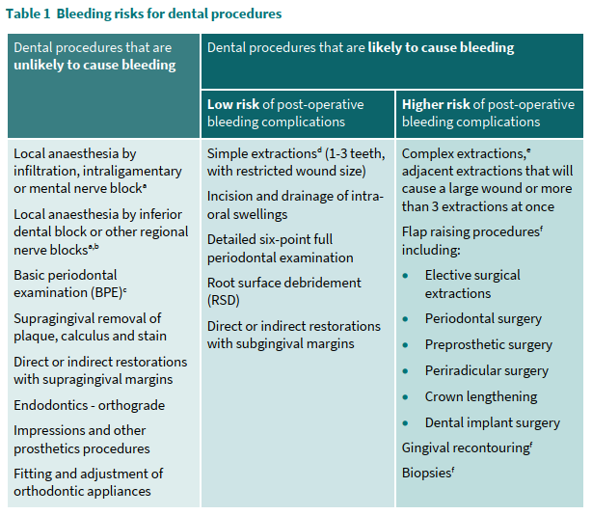
Figure 2: Management of antiplatelet medication (from SDCEP guidelines)
